**EXPERIMENT NO: 3**

**Discrete Time Fourier Transform & Inverse Discrete Time Fourier Transform**

**AIM:** To compute DFT and IDFT of a Discrete Sequence.

**Software used:** Matlab ver-8.6 (R2015b).

**DFT**

**PROGRAM:**

% AIM: To compute DFT and IDFT of a discrete time sequence

clc;

clear all;

x=input('Enter the sequence');

N=length(x);

subplot(2,2,1);

stem(x);

title('x(n)');

ylabel('Amplitude');

xlabel('Samples');

X=zeros(1,N);

for k=0:N-1;

for n=0:N-1;

X(k+1)=X(k+1)+x(n+1)*exp(-1j*2*pi*n*k/N);

end

end

disp(X);

subplot(2,2,2);

stem(X);

title('X(k)');

ylabel('Imaginery axis');

xlabel('Real axis');

subplot(2,2,3);

stem(real(X));

title('Real part of (X)');

ylabel('Imaginery axis');

xlabel('Real axis');

subplot(2,2,4);

stem(imag(X));

title('Imaginery part of X(k)');

ylabel('Imaginery axis');

xlabel('Real axis');

gtext('Jatin Rai:03');

**OUTPUT: DFT**

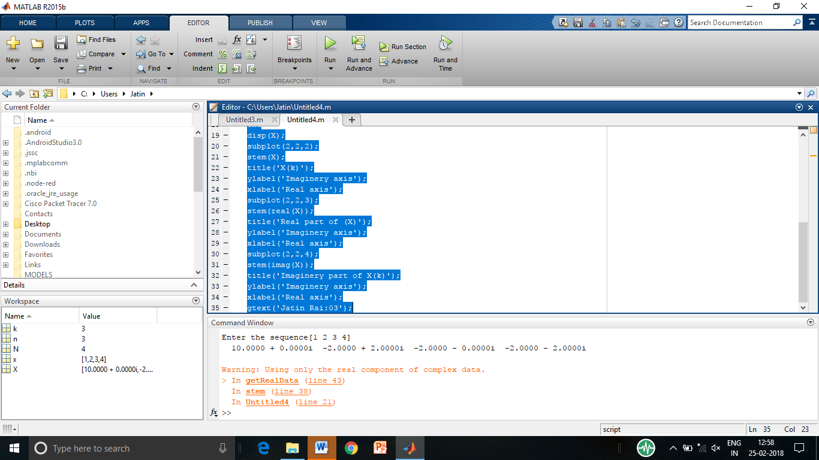



**IDFT**

**PROGRAM:**

% AIM: To compute DFT and IDFT of a discrete time sequence

clc;

clear all;

x=input('Enter the sequence');

N=length(x);

subplot(2,2,1);

stem(x);

title('input X(k)');

ylabel('Amplitude');

xlabel('Samples');

X=zeros(1,N);

for k=0:N-1;

for n=0:N-1;

X(n+1)=X(n+1)+x(k+1)*exp(1j*2*pi*n*k/N);

end

end

disp(X/4);

subplot(2,2,2);

stem(X/4);

title('IDFT of X(k)');

ylabel('Imaginery axis');

xlabel('Real axis');

subplot(2,2,3);

stem(real(x));

title('Real part of X(k)');

ylabel('Imaginery axis');

xlabel('Real axis');

subplot(2,2,4);

stem(imag(x));

title('Imaginery part of X(k)');

ylabel('Imaginery axis');

xlabel('Real axis');

gtext('Pranay Vora:03');

**OUTPUT**: **IDFT**

